愛校建言網頁(http://140.136.251.66/LoveSchool/)
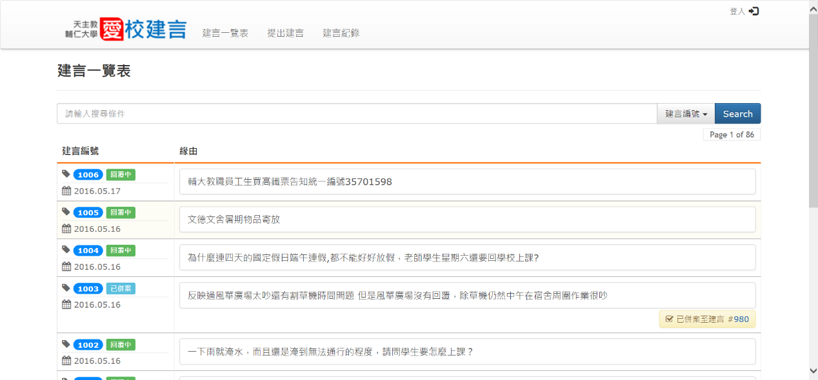

key | 內容 | 英譯
 | 登入 | Log in
 | 天主教輔仁大學愛校建言 | Fu Jen Catholic University Suggestions for Improvement
 | 建言一覽表 | Suggestions
 | 提出建言 | Make a Suggestion
 | 建言紀錄 | My Suggestions
 | 建言一覽表 | Suggestions
 | 建言編號▼ | Number
 | Search
 | Page 1 of 86
 | 建言編號 | Number
 | 緣由 | Topic
PS:本籍生之建言無須翻譯，僅須讓外籍生能使用建言功能及閱覽自身的建言，其餘同學建言仍是中文呈現。

一、登入系統
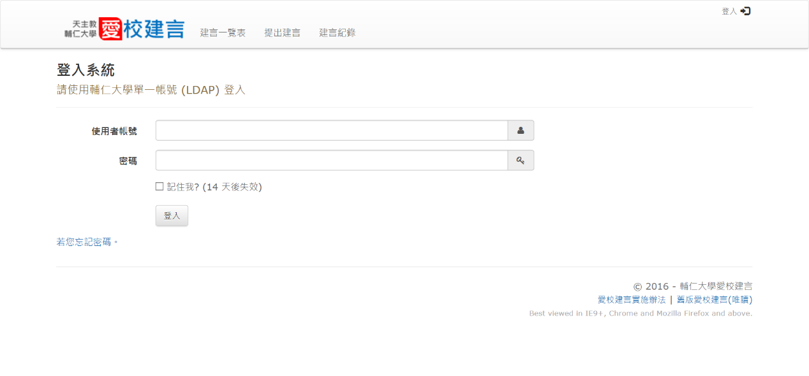

key | 內容 | 英譯
 | 登入 | Log in
 | 天主教輔仁大學愛校建言 | Fu Jen Catholic University Suggestions for Improvement
 | 建言一覽表 | Suggestions
 | 提出建言 | Make a Suggestion
 | 建言紀錄 | My Suggestions
 | 登入系統 | Log in
 | 請使用輔仁大學單一帳號 (LDAP) 登入 | Please log in with your LDAP account and password
 | 使用者帳號 | Account Number
 | 密碼 | Password
 | □記住我? (14 天後失效) | Remember Me (expires after 14 days)
 | 登入 | Log in
 | 若您忘記密碼。 | Forgot password?
 | © 2016 - 輔仁大學愛校建言 | Fu Jen Catholic University Suggestions for Improvement © 2016
 | 愛校建言實施辦法 | 舊版愛校建言(唯讀) | Regulations Governing Suggestions for Improvement/  Old Version (read-only)
 | Best viewed in IE9+, Chrome and Mozilla Firefox and above.

二、建言一覽表
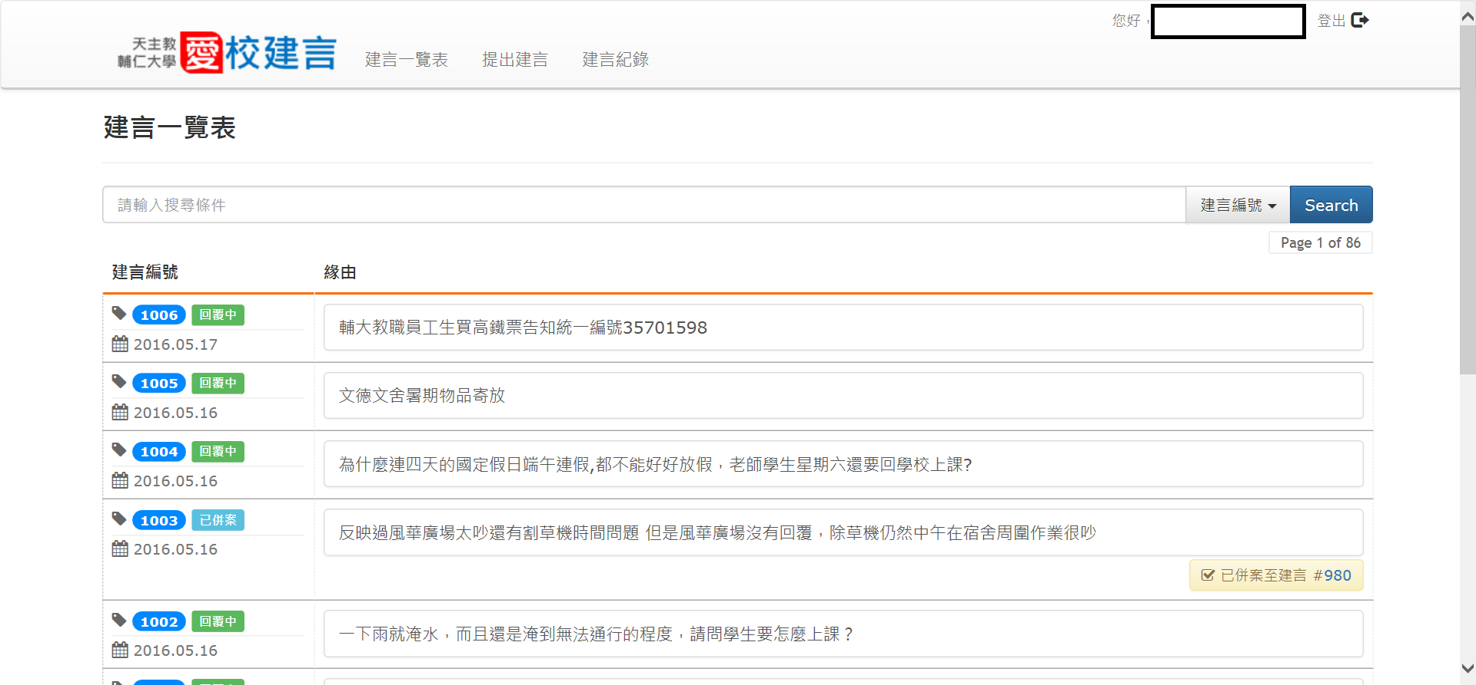

key | 內容 | 英譯
 | 你好，○○○(○○○○○○○○○)登出 | Hello, XXX Log out
 | 天主教輔仁大學愛校建言 | Fu Jen Catholic University Suggestions for Improvement
 | 建言一覽表 | Suggestions
 | 提出建言 | Make a Suggestion
 | 建言紀錄 | My Suggestions
 | 建言一覽表 | Suggestions
 | 建言編號▼ | Number
 | Search
 | Page 1 of 86
 | 建言編號 | Number
 | 緣由 | Topic

三、建言提出
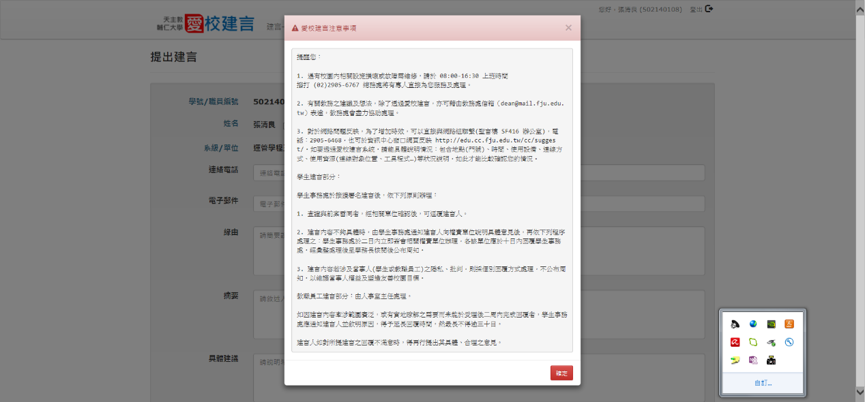

key | 內容 | 英譯
 | 愛校建言注意事項 | Notice
 | 提醒您：  1. 遇有校園內相關設施損壞或故障需維修，請於 08:00-16:30 上班時間  撥打 (02)2905-6767 總務處將有專人直接為您服務及處理。 | Reminder:  - If any facilities or equipment on campus are in need of repair, please call the Office of General Affairs: 02-2905-6767  Office hours:  Monday to Friday  8:00-16:30
 | 2. 有關教務之建議及想法，除了透過愛校建言，亦可藉由教務處信箱（dean@mail.fju.edu.tw）表達，教務處會盡力協助處理。 | 2. Thoughts or suggestions about academic affairs can be expressed here or by emailing the Office of Academic Affairs: dean@mail.fju.edu.tw
 | 3. 對於網路問題反映，為了增加時效，可以直接與網路組聯繫(聖言樓 SF416 辦公室)，電話：2905-6468，也可於資訊中心窗口網頁反映 http://edu.cc.fju.edu.tw/cc/suggest/。如要透過愛校建言系統，請能具體說明情況：包含地點(門號)、時間、使用設備、連線方式、使用資源(連線對象位置、工具程式…)等狀況說明，如此才能比較確認您的情況。 | 3. For matters related to the Internet or campus network, please contact the Network Management Division directly (Divine Word Academic Highrise; Room: SF416; Phone: 2905-6468). You can also let us know through the website for the Center of Information Technology:  http://edu.cc.fju.edu.tw/cc/suggest/  If you would like to make a suggestion on this system, please provide the following details: the place or room number where you encountered the problem, when the problem occurred, what facilities or equipment you were using, how you were connected to the internet, and what resources you tried to use (websites, software, etc.). These details will help us solve your problem more quickly.
 | 學生建言部分：  學生事務處於接獲署名建言後，依下列原則辦理： | Student suggestions:  The Office of Student Affairs will handle a suggestion that includes your name as follows:
 | 1.查證與前案雷同者，經相關單位確認後，可逕覆建言人。 | Check to see if any similar suggestions have been made. If there are suggestions of a similar nature, the office may handle the suggestions as one or provide a common response.
 | 2.建言內容不夠具體時，由學生事務處通知建言人向權責單位說明具體意見後，再依下列程序處理之：學生事務處於二日內立即簽會相關權責單位辦理，各該單位應於十日內回覆學生事務處，經彙整處理後呈學務長核閱後公布周知。 | If your suggestion lacks specific details, the Office of Student Affairs will contact you and ask for more information. Your suggestion will then be handled according to the following procedure: the Office of Student Affairs will transfer the suggestion to all related authorities within two days. Each authority will provide a response to the Office of Student Affairs within 10 days after receiving the suggestion. Their responses will be organized into a decision, which will then be presented to the dean of the Office of Student Affairs. Following approval, the decision will be published.
 | 3.建言內容若涉及當事人(學生或教職員工)之隱私、批判，則採個別回覆方式處理，不公布周知，以維護當事人權益及塑造友善校園目標。 | If your suggestion criticizes or involves the privacy of a student, faculty member, or staff member, the University will respond to you privately, and no decision will be published, in order to protect the rights and interests of the parties involved and maintain a friendly campus environment.
 | 教職員工建言部分：由人事室主任處理。 | Faculty and staff members: Suggestions are handled by the Personnel Office.
 | 如因建言內容牽涉範圍廣泛，或有實地瞭解之需要而未能於受理後二周內完成回覆者，學生事務處應通知建言人並敘明原因，得予延長回覆時間，然最長不得逾三十日。 | If the scope of your suggestion is broad-ranging, or if it requires greater comprehension, and therefore a response cannot be made within two weeks, the Office of Student Affairs will notify you and explain the reasons for delay. The response time may be extended, but not for a period exceeding 30 days.
 | 建言人如對所提建言之回覆不滿意時，得再行提出其具體、合理之意見。 | If you are not satisfied with the response, you may once again raise a reasonable request that includes specific details.
 | 確定 | Send

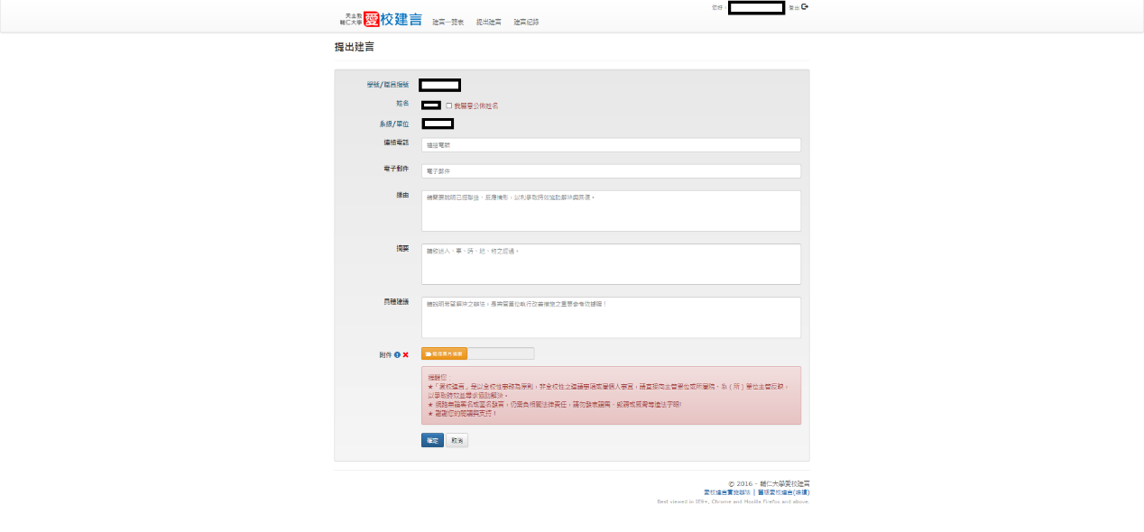

key | 內容 | 英譯
 | 你好，○○○(○○○○○○○○○)登出 | Hello, XXX Log out
 | 天主教輔仁大學愛校建言 | Fu Jen Catholic University Suggestions for Improvement
 | 建言一覽表 | Suggestions
 | 提出建言 | Make a Suggestion
 | 建言紀錄 | My Suggestions
 | 提出建言 | Make a Suggestion
 | 學號/職員編號 | Student/Staff ID
 | 姓名 | Name
 | □我願意公佈姓名 | I grant permission for my name to be posted
 | 系級/單位 | Program and Year of Study/Place of work
 | 連絡電話 | Contact Phone
 | 電子郵件 | Email
 | 緣由 | Topic
 | 摘要 | Details
 | 具體建議 | What action would you like to see taken?
 | 附件 | Attachment
 | 選擇圖片檔案 | Select picture file
 | 提醒您：  ★「愛校建言」是以全校性事務為原則，非全校性之建議事項或屬個人事宜，請直接向主管單位或所屬院、系（所）單位主管反映，以爭取時效並尋求協助解決。 | Reminder:  Your suggestion should be related to the general affairs of the University. If it is related to a personal matter, or if it is not related to the University as a whole, please make it directly to the competent authority or to the college, department, or institute responsible in order to receive a quick resolution.
 | ★ 網路無論署名或匿名發言，仍需負相關法律責任，請勿發表謾罵、毀謗或威脅等違法字眼! | You will be held legally responsible for posts using your real name or a false one. Please do not post anything abusive, slanderous, or threatening.
 | ★ 謝謝您的閱讀與支持！ | Thank you for your support!
 | 確定 | Send
 | 取消 | Cancel
 | © 2016 - 輔仁大學愛校建言 | Fu Jen Catholic University Suggestions for Improvement© 2016
 | 愛校建言實施辦法 | 舊版愛校建言(唯讀) | Regulations Governing Suggestions for Improvement/Old Version (read-only)
 | Best viewed in IE9+, Chrome and Mozilla Firefox and above.

四、建言紀錄
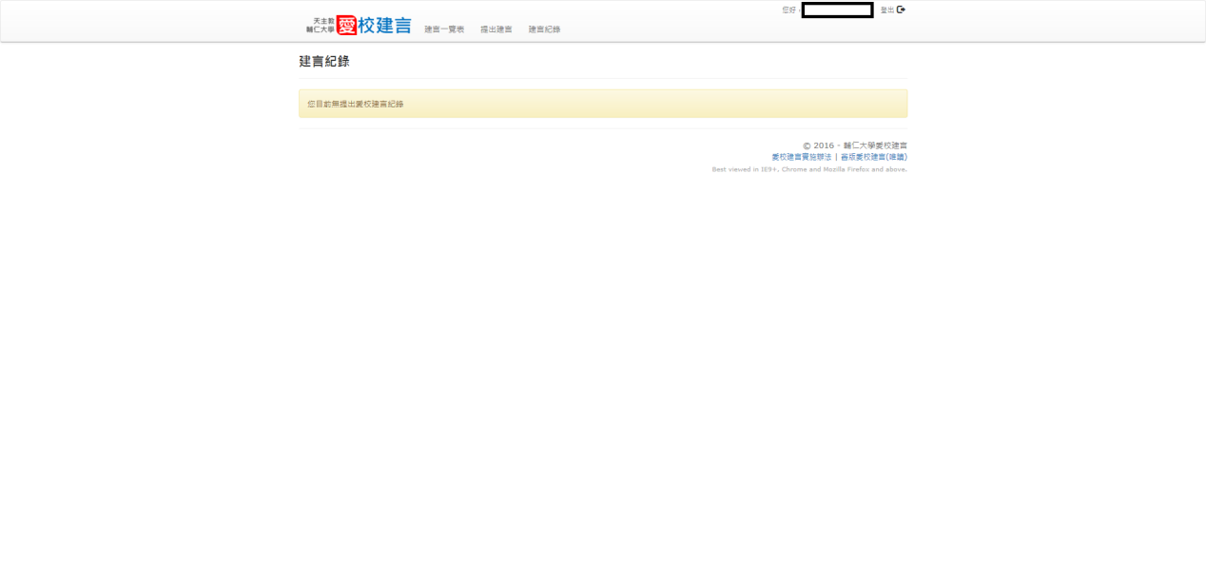
key | 內容 | 英譯
 | 你好，○○○(○○○○○○○○○)登出 | Hello, XXX Log out
 | 天主教輔仁大學愛校建言 | Fu Jen Catholic University Suggestions for Improvement
 | 建言一覽表 | Suggestions
 | 提出建言 | Make a Suggestion
 | 建言紀錄 | My Suggestions
 | 建言紀錄 | My Suggestions
 | 您目前無提出愛校建言紀錄 | You have not made any suggestions
 | © 2016 - 輔仁大學愛校建言 | Fu Jen Catholic University Suggestion for Improvement © 2016
 | 愛校建言實施辦法 | 舊版愛校建言(唯讀) | Regulations Governing Suggestions for Improvement/Old Version (read-only)
 | Best viewed in IE9+, Chrome and Mozilla Firefox and above.

