學生事務處獎（助）學金資訊系統
一、登入系統
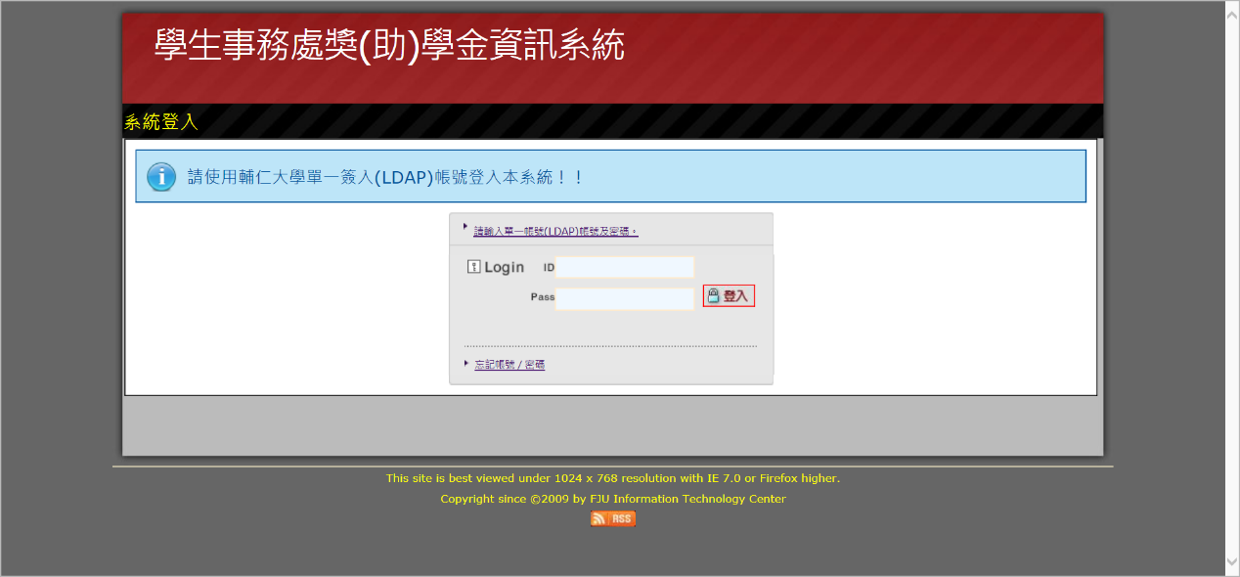

key | 內容 | 英譯
 | 學生事務處獎（助）學金資訊系統 | Information System for Scholarships and Bursaries
 | 登入系統 | Log in
 | 輸入個人之單一簽入(LDAP)帳號及密碼 | Please enter your LDAP account number and password
 | 執行，進入系統 | Logging in

二、進入系統
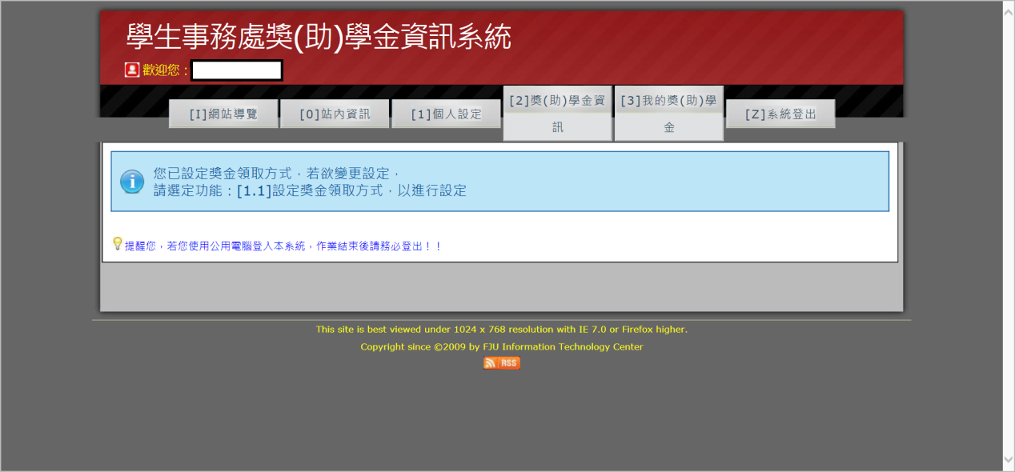

key | 內容 | 英譯
 | [I]網站導覽 | Options
 | [0]站內資訊 | Information
 | [1]個人設定 | Personal Settings
 | [2]獎(助)學金資訊 | Scholarship and Bursary Information
 | [3]我的獎(助)學金 | My Scholarships/Bursaries
 | [Z]系統登出 | Log out
 | 提醒您，若您使用公用電腦登入本系統，作業結束後請務必登出！！ | Reminder:  If you are using a public computer, please remember to log out when you have finished.

三、個別子系統
1. [0]站內資訊
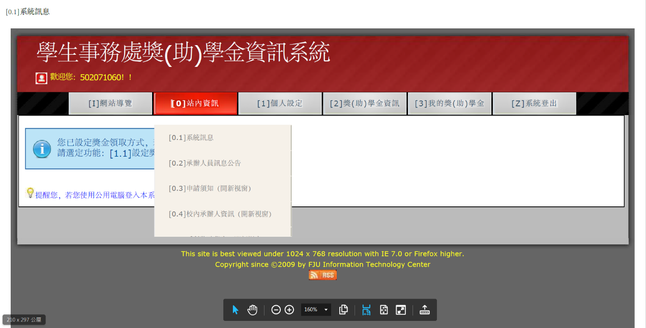
key | 內容 | 英譯
 | [0.1]系統資訊 | System Information
 | [0.2]承辦人員訊息公告 | Announcements
 | [0.3]申請須知(開新視窗) | Important Information for Scholarships and Bursaries (open in new window)
 | [0.4]校內承辦人資訊(開新視窗) | Scholarship and Recipient Information (open in new window)
 | [0.5]系所獎助學金(開新視窗) | Program-Specific Scholarships and Bursaries (open in new window)
 | 提醒您，若您使用公用電腦登入本系統，作業結束後請務必登出！！ | Reminder:  If you are using a public computer, please remember to log out when you have finished.

1.1[0.2]承辦人員訊息公告
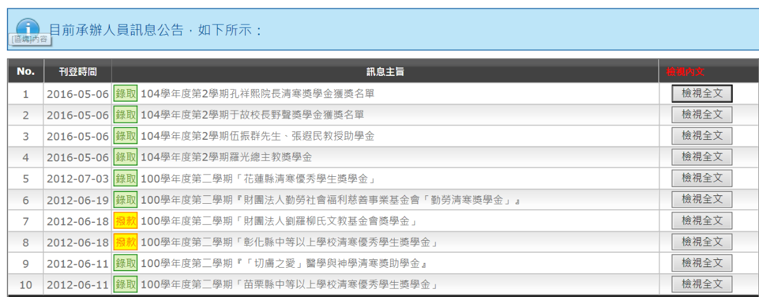
key | 內容 | 英譯
 | 目前承辦人員訊息公告，如下所示： | Current Announcements
 | No.
 | 刊登時間 | Date Posted
 | 訊息主題 | Topic
 | 檢視內文 | Details
 | 1
 | 2016-05-06
 | 錄取、撥款、一般、緊急 | Results/Remittance /General/Urgent
 | 錄取 104學年度第2學期孔祥熙院長清寒獎學金獲獎名單 | Results - List of recipients for the Hsiang-hsi Kung Scholarship for Low-Income Students for the second semester of the 2015-2016 academic year
 | 撥款 100學年度第二學期「財團法人劉羅柳氏文教基金會獎學金」 | Remittance – Liu, Luo, and Liu Cultural and Educational Foundation Scholarship
 | 提醒您，若您使用公用電腦登入本系統，作業結束後請務必登出！！ | Reminder:  If you are using a public computer, please remember to log out when you have finished.

1.2[0.3]申請須知(開新視窗)
獎助學金申請須知.pdf(附件一)
PS:這是PDF檔
1.3[0.4]校內承辦人資訊(開新視窗)
http://life.dsa.fju.edu.tw/scholarship.html
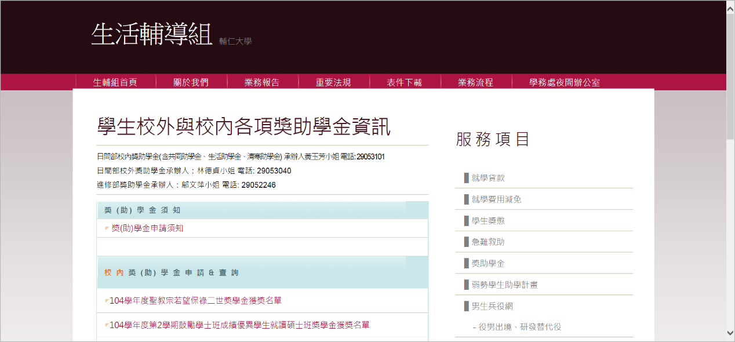
PS:因為這是連生輔組網頁就不須重覆翻譯
2. [1]個人設定
2.1[1.1]設定獎金領取方式
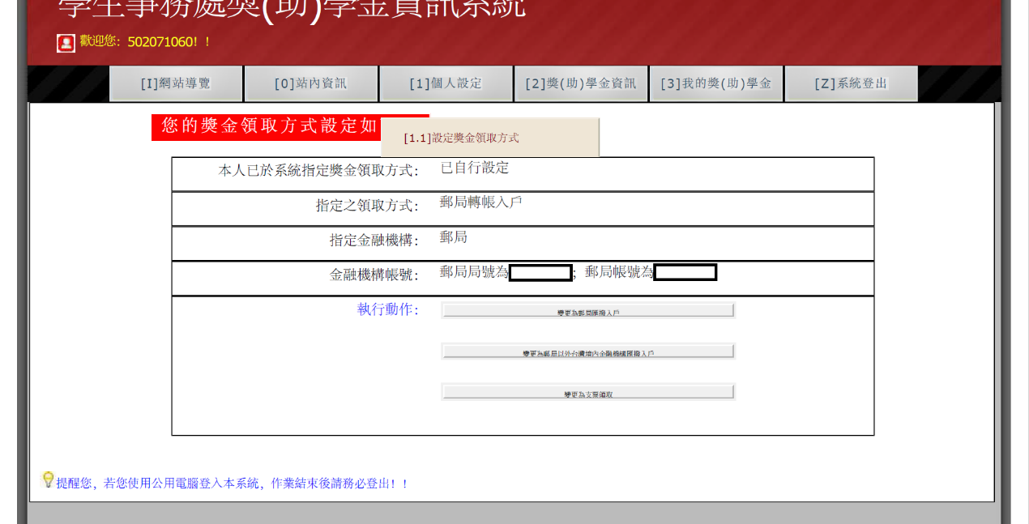
key | 內容 | 英譯
 | [1.1]設定獎金領取方式 | Select how you would like to collect the scholarship or bursary money
 | 提醒您，若您使用公用電腦登入本系統，作業結束後請務必登出！！ | Reminder:  If you are using a public computer, please remember to log out when you have finished.

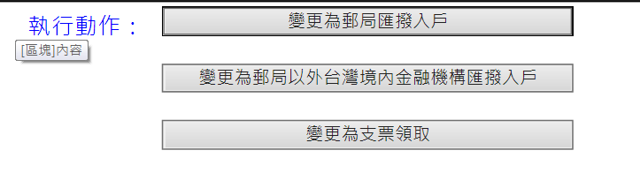
key | 內容 | 英譯
 | 執行動作 | Options
 | 變更為郵局匯撥入戶 | Remittance to Chunghwa Post Office account
 | 變更為郵局以外台灣境內金融機構匯撥入戶 | Remittance to a bank account in Taiwan
 | 變更為支票領取 | By check
 | 提醒您，若您使用公用電腦登入本系統，作業結束後請務必登出！！ | Reminder:  If you are using a public computer, please remember to log out when you have finished.
2.2郵局匯撥
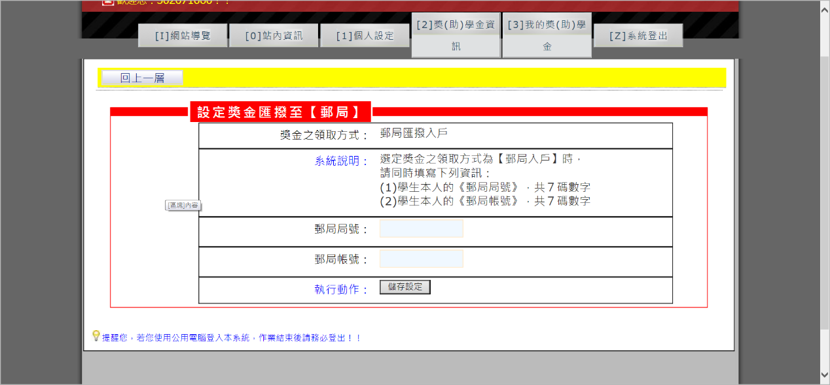

key | 內容 | 英譯
 | 回上一層 | Previous
 | 設定獎金匯撥至[郵局] | Set up remittance to Chunghwa Post Office account
 | 獎金之領取方式:郵局匯撥入戶 | Collection Method: Remittance to Chunghwa Post Office
 | 系統說明:選定獎金之領取方式為[郵局入戶]時，請同學填寫下列資訊:  (1)學生本人(郵局局號):共7碼數字  (2) 學生本人(郵局帳號):共7碼數字 | Details:  If you would like to collect the scholarship money by remittance to your Chunghwa Post Office account, please provide the following information:  - The branch number for the Chunghwa Post Office where you opened your personal account (7 digits)  - The account number of your personal account (7 digits)
 | 郵局局號: | Branch number:
 | 郵局帳號: | Account number:
 | 執行動作:儲存設定 | Save settings
 | 提醒您，若您使用公用電腦登入本系統，作業結束後請務必登出！！ | Reminder:  If you are using a public computer, please remember to log out when you have finished.

2.3郵局以外台灣境內金融機構
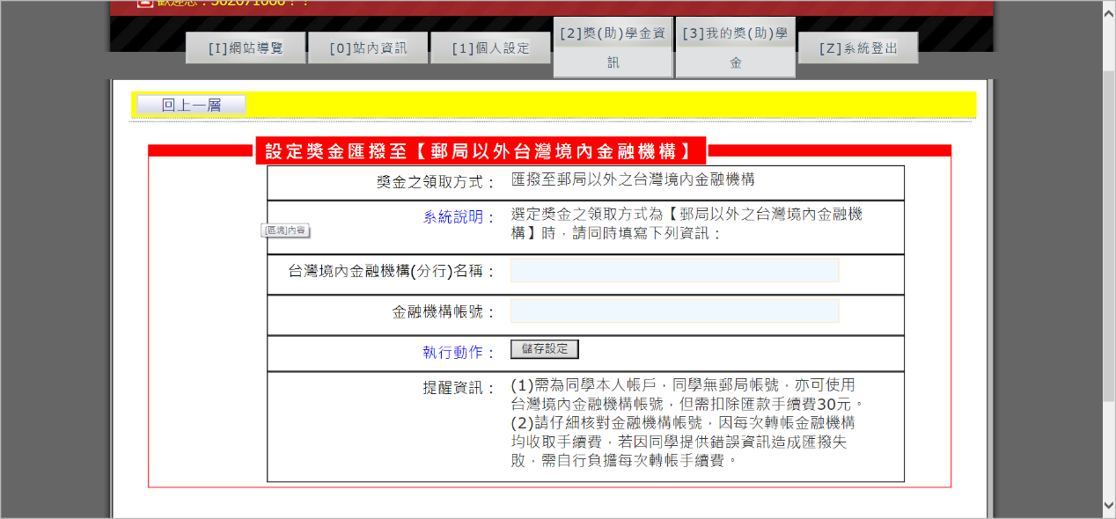

key | 內容 | 英譯
 | 回上一層 | Previous
 | 設定獎金匯撥至[郵局以外台灣境內金融機構] | Set up remittance to a bank account in Taiwan
 | 獎金之領取方式:匯撥至郵局以外台灣境內金融機構 | Collection Method: Remittance to a bank account in Taiwan
 | 系統說明:選定獎金之領取方式為[郵局以外台灣境內金融機構]時，請同學填寫下列資訊: | Details:  If you would like to collect the scholarship money by remittance to your bank account, please provide the following information:
 | 台灣境內金融機構(分行)名稱: | Name of your bank (including branch):
 | 金融機構帳號: | Account number:
 | 執行動作:儲存設定 | Settings saved
 | 提醒資訊:(1)須為同學本人帳戶，同學無郵局帳號亦可使用台灣境內金融機構帳號，但須扣除匯款手續費30元。  (2)請仔細核對金融機構帳號，因每次轉帳金融機構均收取手續費，若因同學提供錯誤資訊造成匯撥失敗，需自行負擔每次轉帳手續費。 | Reminder: (1) The account you provide must be your own personal account. If you do not have an account at the Chunghwa Post Office, you can provide an account from any bank in Taiwan, but you will be charged a service fee of NT$30.  - Please make sure the account number you provide is accurate. A service fee is charged for each transaction. If the transaction fails because of incorrect information, you will be charged additional service fees.
 | 提醒您，若您使用公用電腦登入本系統，作業結束後請務必登出！！ | Reminder:  If you are using a public computer, please remember to log out when you have finished.

2.4支票
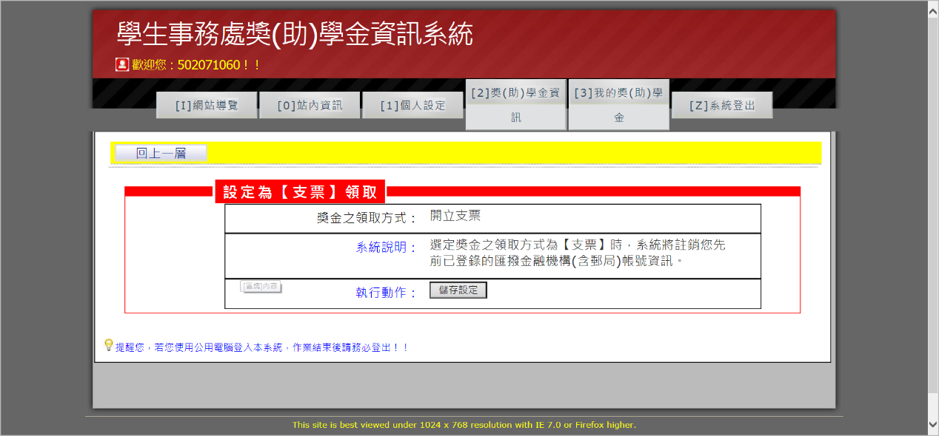

key | 內容 | 英譯
 | 回上一層 | Previous
 | 設定為[支票]領取 | Set up collection by check
 | 獎金之領取方式:開立支票 | Collection Method: By Check
 | 系統說明:選定獎金之領取方式為[支票]時，系統將註銷先前已登錄的匯撥金融機構(含郵局)帳號資訊。 | Details: If you would like to collect the scholarship money by check, the system will delete any information you have entered for an account at the Chunghwa Post Office or another bank.
 | 執行動作:儲存設定 | Save settings
 | 提醒您，若您使用公用電腦登入本系統，作業結束後請務必登出！！ | Reminder:  If you are using a public computer, please remember to log out when you have finished.

3.獎(助)學金資訊
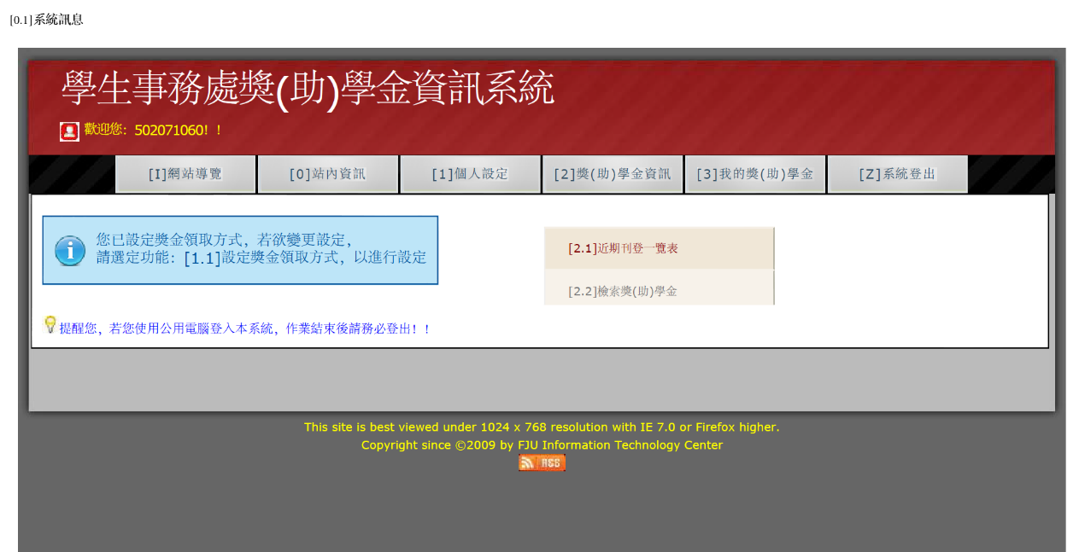
key | 內容 | 英譯
 | [2.1]近期刊登一覽表 | Recent Posts
 | [2.2]檢索獎學金 | Search for scholarships/bursaries
 | 提醒您，若您使用公用電腦登入本系統，作業結束後請務必登出！！ | Reminder:  If you are using a public computer, please remember to log out when you have finished.

3.1[2.1]近期刊登一覽表
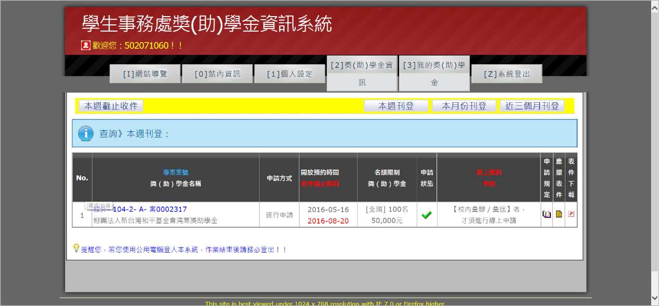

key | 內容 | 英譯
 | 本週截止收件 | Deadlines for this week
 | 本週刊登 | View posts from this week
 | 本月刊登 | View posts from this month
 | 近三個月刊登 | View posts from past 3 months
 | 查詢》本週刊登：  查詢》本月份刊登：  查詢》近三個月刊登： | Search posts from this week  Search posts from this month  Search posts from past 3 months
 | 專案案號  獎（助）學金名稱 | Code  Name of scholarship/bursary
 | 申請方式 | Application Method
 | 開放預約時間  收件截止時間 | When to apply
 | 名額限制  獎（助）學金 | Quota  Value
 | 申請  狀態 | Application Status
 | 線上預約  申請 | Online Pre-application
 | 申請規定 | Regulations for Applying
 | 應繳表件 | Required Documents
 | 表件下載 | Download Forms
 | 校內- 105-1- B- 案0002312  生活助學金 | Fu Jen – 105-1-B- Case No. 0002312  Living Allowance
 | 校內彙辦／彙送、逕行申請、院系所／校內單位推薦 | Application through University/Individual Application/Recommendation by Program or Division
2016-06-01
2016-06-17
 | [輔大] 不限 0元～6,000元、[全國] 不限 0元～6,000元 | Quota: None  Value: NT$0-NT$6,000
 | 將於《2016-06-01》開放、【校內彙辦／彙送】者，才須進行線上申請、、已截止，下次請早 | Applications can be made starting from June 1, 2016. If the scholarship or bursary is made by Application through University, you must pre-apply online. If the deadline has already passed, please apply earlier next time.
 | 提醒您，若您使用公用電腦登入本系統，作業結束後請務必登出！！ | Reminder:  If you are using a public computer, please remember to log out when you have finished.

3.2[2.2]檢索獎學金
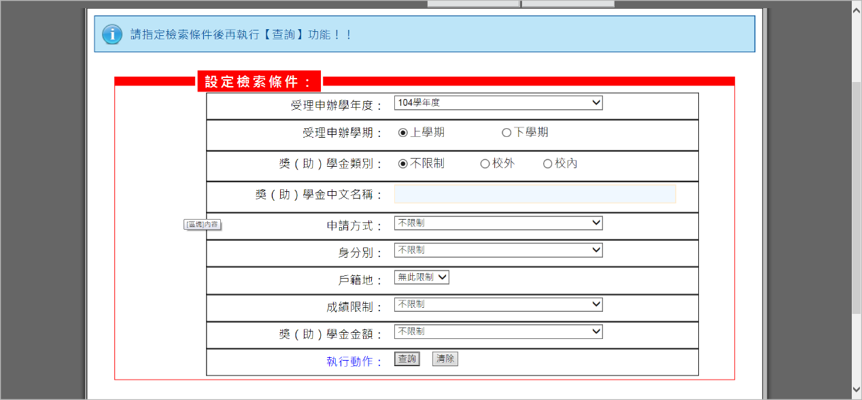
key | 內容 | 英譯
 | 請指定檢索條件後再執行[查詢]功能!! | Please fill out the information below before searching.
 | 設定檢索條件 | Set search parameters
 | 受理申辦學年度:104學年度 | Academic Year: 2015-2016
 | 受理申辦學期:○上學期 ○下學期 | Semester:  ○First ○Second
 | 獎(助)學金類別:○不限制 ○校內 ○校外 | Category: ○All ○Fu Jen  ○Outside Source
 | 獎(助)學金中文名稱: | Chinese name of scholarship/bursary:
 | 申辦方式:不限制、校內彙辦／彙送、逕行申請、院系所／校內單位推薦 | Application Method: ○All  - Application through University  - Individual Application  - Recommendation by Program or Division
 | 身分別: 不限制、中華民國國民、身心障礙、原住民、僑生、外籍生、申請附註另行規定 | Status Restrictions: None, R.O.C. citizens, disabled students, aboriginal students, overseas Chinese students, international students, other
 | 戶籍地: | Registered Residence
 | 成績限制:不限制、有限制、無限制 | Restrictions based on academic grades: None, Yes, No
 | 獎(助)學金金額:最少1000、最少3000、最少5000、最少10000 | Value:  NT$1,000 minimum, NT$3,000 minimum, NT$5,000 minimum, NT$10,000 minimum
 | 執行動作:查詢 清除 | Search/Clear
 | 提醒您，若您使用公用電腦登入本系統，作業結束後請務必登出！！ | Reminder:  If you are using a public computer, please remember to log out when you have finished.

4.我的獎助學金
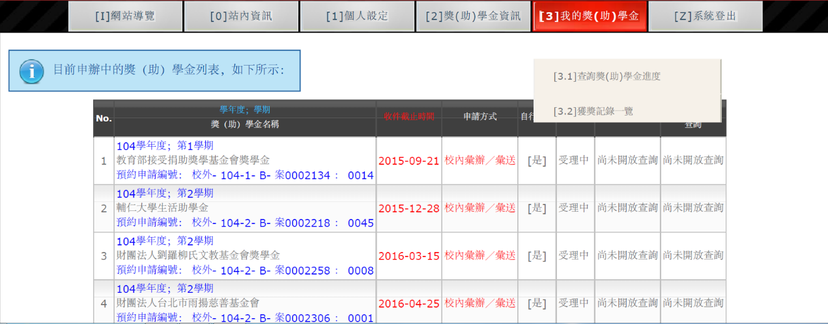
key | 內容 | 英譯
 | [4.1]查詢獎助學金進度 | Check review status
 | [4.2]獲獎紀錄一覽表 | List of awards
 | 提醒您，若您使用公用電腦登入本系統，作業結束後請務必登出！！ | Reminder:  If you are using a public computer, please remember to log out when you have finished.

4.1[4.1]查詢獎助學金進度
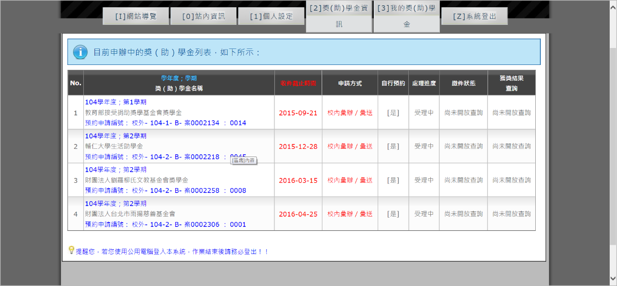
key | 內容 | 英譯
 | 目前申辦中的獎（助）學金列表，如下所示： | You are currently applying for the following:
 | No.
 | 學年度；學期  獎（助）學金名稱 | Semester/Academic Year  Name of scholarship/bursary
 | 收件截止時間 | Deadline
 | 申請方式 | Application method
 | 自行預約 | Pre-apply
 | 處理進度 | Phase
 | 繳件狀態 | Status
 | 獲獎結果  查詢 | Search for Results
 | 1
 | 104學年度；第1學期  教育部接受捐助獎學基金會獎學金  預約申請編號： 校外- 104-1- B- 案0002134 ： 0014 | First Semester, 2015-2016 Academic Year  MOE Donation Fund Scholarship  Pre-application code: Other source – 2015-1 – B – Case No. 0002134: 0014
 | 2015-09-21
 | 校內彙辦／彙送、逕行申請、院系所／校內單位推薦 | Application through University, Individual Application, Recommendation by Program or Division
 | [是] | Yes
 | 受理中 | Processing
 | 尚未開放查詢 | Search currently unavailable
 | 尚未開放查詢
 | 提醒您，若您使用公用電腦登入本系統，作業結束後請務必登出！！ | Reminder:  If you are using a public computer, please remember to log out when you have finished.

4.2[4.2]獲獎紀錄一覽表
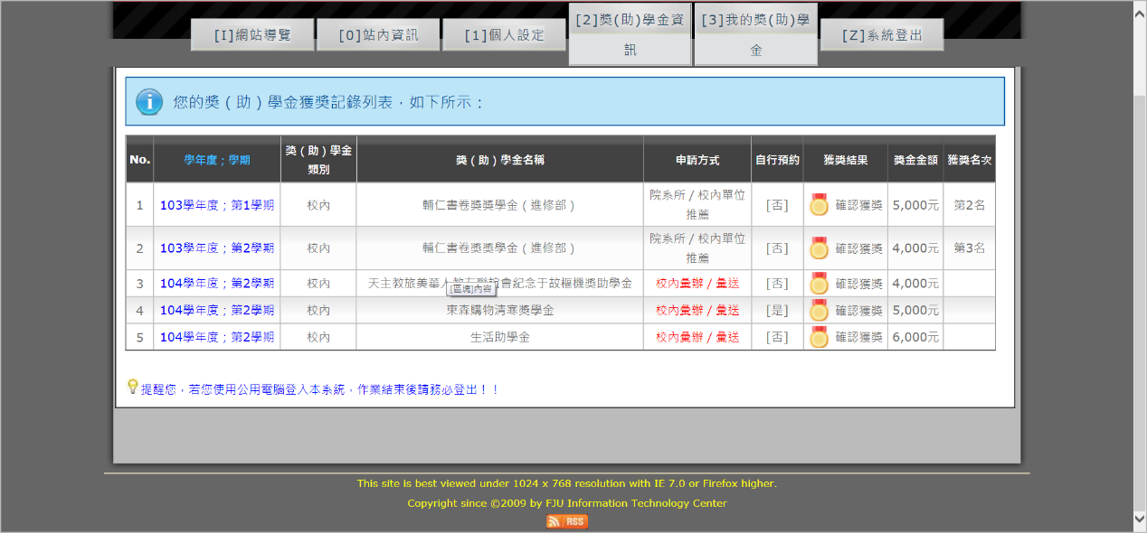
key | 內容 | 英譯
 | No.
 | 學年度；學期 | Semester; Academic Year
 | 獎（助）學金  類別 | Scholarship/Bursary Category
 | 獎（助）學金名稱 | Name of Scholarship/Bursary
 | 申請方式 | Application Method
 | 自行預約 | Pre-apply
 | 獲獎結果 | Result
 | 獎金金額 | Value
 | 獲獎名次 | Rank
 | 1
 | 103學年度；第1學期、第2學期 | 2014-2015 Academic Year; First Semester, Second Semester
 | 校內、校外 | Fu Jen, Other Source
 | 天主教旅美華人教友聯誼會紀念于故樞機獎助學金 | Association of Chinese Catholics in America Cardinal Yu Memorial Scholarship
 | 校內彙辦／彙送、逕行申請、院系所／校內單位推薦 | Application through University, Individual Application, Recommendation by Program or Division
 | [否]、[是] | Yes No
 | 確認獲獎 | Congratulations!
 | 5,000元 | NT$5,000
 | 第1名、第2名、第3名 | First, Second, Third
 | 提醒您，若您使用公用電腦登入本系統，作業結束後請務必登出！！ | Reminder:  If you are using a public computer, please remember to log out when you have finished.

5. [Z]系統登出
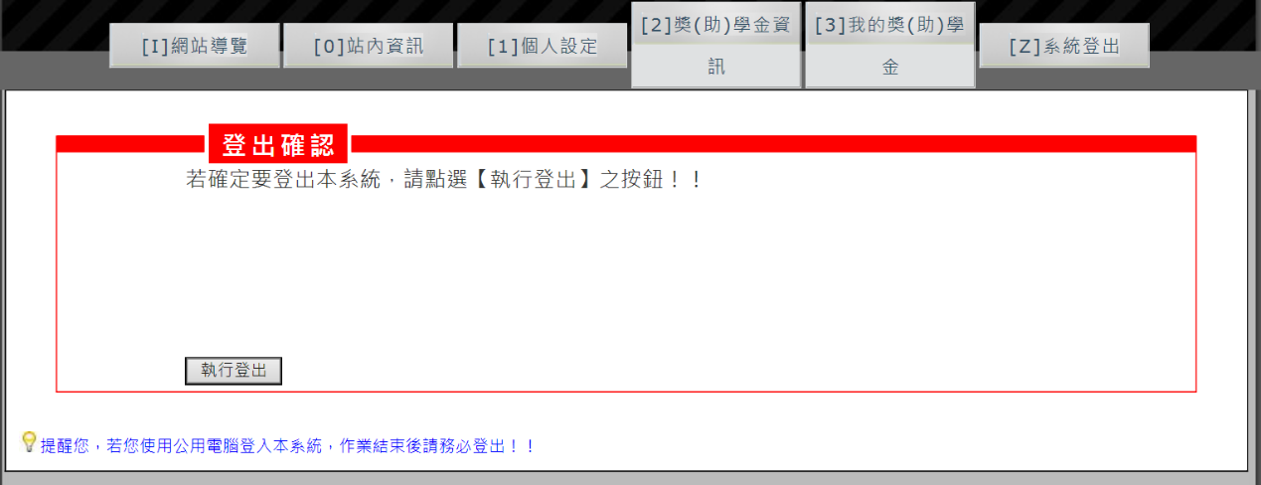
key | 內容 | 英譯
 | 登出確認 | Log out
 | 若確定要登出本系統，請點選【執行登出】之按鈕！！ | If you would like to leave the system, please click Log Out
 | 執行登出 | Log Out
 | 提醒您，若您使用公用電腦登入本系統，作業結束後請務必登出！！ | Reminder:  If you are using a public computer, please remember to log out when you have finished.

